**Project Design Phase-I**

**Solution Architecture**

|  |  |
| --- | --- |
| Date | 28 OCTOBER 2023 |
| Team ID | NM2023TMID02040 |
| Project Name | FOOD TRACKING SYSTEM |
| Maximum Marks | 4 Marks |

**Solution Architecture:**

A food tracking system utilizing blockchain technology can enhance transparency and traceability within the food supply chain. The project's solution architecture would consist of several key components.

First, a decentralized blockchain network would be established to record every step of the food production and distribution process. Each participant, such as farmers, processors, distributors, and retailers, would have a unique identity on the blockchain, ensuring accountability.

Smart contracts would automate and enforce agreements, triggering actions based on predefined conditions, such as quality inspections, temperature monitoring, and delivery schedules. These contracts can provide real-time visibility into the status of food products.

Immutable records on the blockchain would create an auditable and tamper-resistant ledger, enhancing food safety and quality control. Consumers could access this data through a user-friendly interface or mobile app, scanning QR codes on products for detailed information about their origin, safety standards, and expiration dates.

The utilization of blockchain technology in a food tracking system can improve food safety, reduce fraud, and increase consumer trust in the supply chain.

**SOLUTION ARCHITECTURE:**

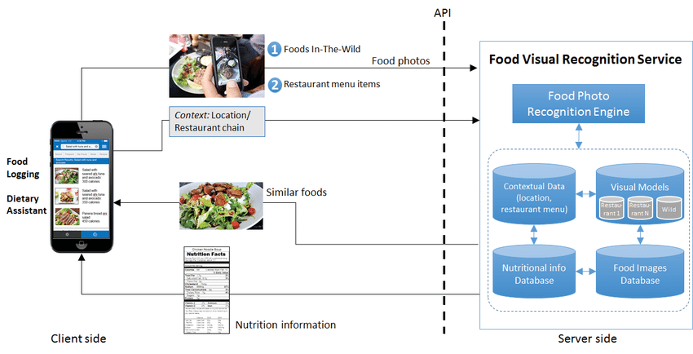

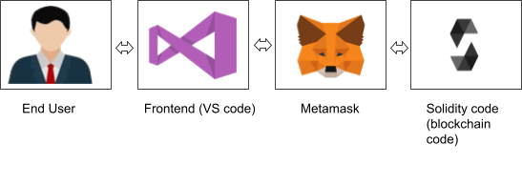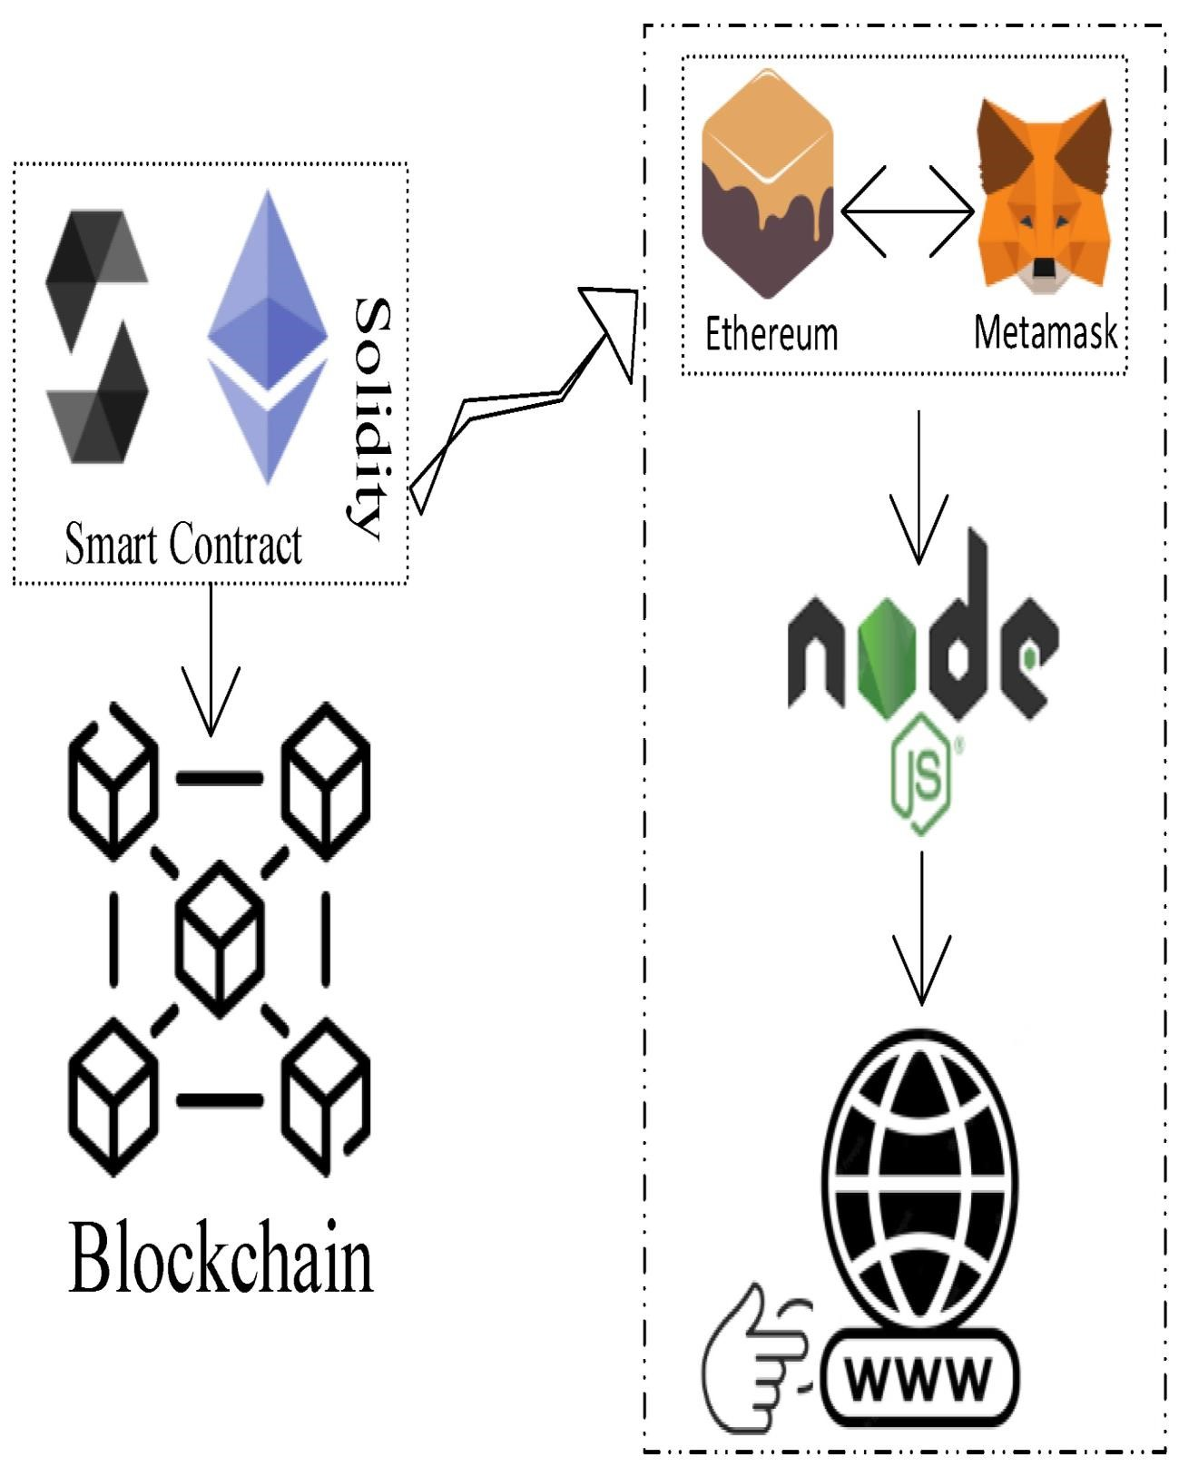

**Prerequisite**

1. download node.js : [Node.js](https://nodejs.org/en)
2. download vs code: [**Li4nk**](https://code.visualstudio.com/download)
3. download metamask : <https://metamask.io/>

**Steps to complete the project**

**Step 1:-**

1. Open the Zip file and download the zip file.

Extract all zip files **Step 2 :**

1.Open vs code in the left top select open folder. Select extracted file and open .

1. Select the projectname.sol file and copy the code.
2. Open the remix ide platform and create a new file by giving the name of projectname.sol and paste the code which you copied from vs code.
3. Click on solidity compiler and click compile the projectname.sol
4. Deploy the smart contract by clicking on the deploy and run transaction.
5. select injected provider - MetaMask. In environment
6. Click on deploy. Automatically MetaMask will open and give confirmation. You will get a pop up click on ok.
7. In the Deployed contract you can see one address copy the address.
8. Open vs code and search for the connector.js. In contract.js you can paste the address at the bottom of the code. In export const address.
9. Save the code.

**Step 3:**

open file explorer

1. Open the extracted file and click on the folder.
2. Open src, and search for utiles.

3 . You can see the frontend files. Select all the things at the top in the search bar by clicking alt+ A. Search for cmd

1. Open cmd enter commands

npm install npm bootstrap npm start

1. It will install all the packages and after completing it will open {LOCALHOST IP

ADDRESS} copy the address and open it to chrome so you can see the frontend of your project.